Midlands Society for
Human Resource Management
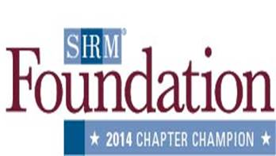
2016 application for membership

I hereby apply for regular membership in accordance with the bylaws of the Midlands Society for Human Resource Management.

Please provide or correct the following information.

Name: Position:
Company:
Address: Phone:
City: Fax:
State: ZIP: Email:

I understand that the contact information I provide will be made available to other MSHRM members and posted on the MSHRM website (http://mshrm.shrm.org/.)

I prefer to receive information from MSHRM by: Postal mail Email Fax

Nature of Company’s Business:

Number of employees: My position is: Exempt Non-exempt
Responsibilities of Position:

(Check one)
I am a member of National SHRM. My membership number is .
I am not a member of National SHRM. Please send me information about the organization.
I am only interested in membership in Midlands SHRM at this time.

I am a certified Human Resources professional: PHR SPHR Other

Membership dues for one calendar year are $100. National SHRM members receive a $10 discount. Membership applications must be returned with payment by February 15. Memberships are individual, not corporate. Other employees may not take your place at a meeting, but may attend as a guest.

In applying for membership in the Midlands Society for Human Resource Management, I recognize and accept the responsibilities incumbent upon me as a member of the Personnel profession. I pledge to constantly observe, practice and maintain the ethical responsibilities of the profession. I agree to abide by the by-laws and to assist in carrying out the goals of the Association.

Applicant’s Signature Date

Mail application with payment to MSHRM Attn: Secretary-Treasurer, PO Box 2564, Orangeburg, SC 29116
Please note that credit or debit card payments cannot be accepted.
For Board Use Only:

Date Received: Approved/Disapproved: ____________________

